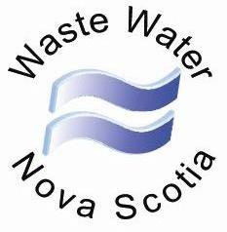

Waste Water Nova Scotia
60 Kyle, Greenwood, NS, B2H 5C7
Phone: 902-246-2131 Fax: 902-246-2130
Email: wastewaterns@eastlink.ca

WWNS
NEWS

February 2022 For the latest of happenings at WWNS, read on…

Spring Meeting

WWNS is planning to hold a virtual meeting in early spring to catch up on business meetings, have an update from Nova Scotia Environment and Climate Change and hold elections for several Board of Director seats.

Gathering restrictions through 2020-2021 have prevented WWNS from holding regular meetings across the province during this period and our large membership base creates challenges that we are working to overcome.

If possible, there may be several remote sites set up for those who do not have access to electronic meetings to allow them to view the presentation. Seating at these locations will be very limited and will depend on provincial guidelines at the time. Details will be made available closer to the date.

Selectable Sloping Sand Filter Update

Nova Scotia Environment and Climate Change (ECC) has received comments on the selectable concept that was shared in October 2021. The selectable concept has been adjusted to reflect the comments.

Work continues to finalize a selectable sloping sand filter option to include in the Standard for use by Qualified Persons. ECC will also develop a training session for Qualified Persons specific to the selectable concept and its use prior to adding it to the Standard.

As usual, contact your local ECC office for any file specific concerns or questions on the Onsite Program. For any general questions, Stefan Furey can be reached at Stefan.furey@novascotia.ca.

With this Issue:

2022 WWNS Membership Application
http://wwns.ca/resource/WWNS_membership_form_2022.pdf

Home Owners Guide to Septic Systems Booklet

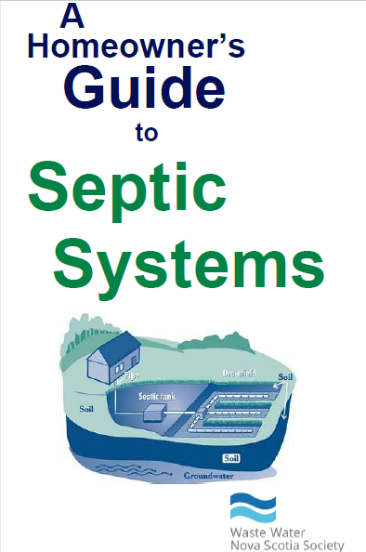
The educational booklet “A Homeowners Guide to Septic Systems” has been distributed by many industry members in the past as a way to educate homeowners on the proper usage and maintenance of their on-site systems. The booklet has been updated and WWNS has a large supply of copies of the booklet available.
If you are interested in receiving copies to distribute to your clients, please contact the WWNS office.

Changes to CSA Standard B66

Any septic tank installed in Nova Scotia must be certified as meeting, or as being equivalent to, CSA Standard B66 “Design, material, and manufacturing requirements for prefabricated septic tanks & sewage holding tanks”.
CSA has recently modified their standard to include a secondary safety device in access risers. The change is highlighted below:

4.2.6.3 Risers
When risers above the tank access opening are provided, the manufacturer shall construct the tank in such a way that all joints between the tank access opening and the risers, as well as between all riser sections, are watertight. All access openings (which are meant to be removed) over chambers with an opening greater than 200 mm in diameter, where there is a risk of accidental entry, shall have a secondary safety device that can withstand 91 kg of dead load.

Nova Scotia Environment and Climate will discuss this change with tank manufacturers this year. Septic tank manufacturers will be expected to meet this new requirement in the future, but at this time the tanks can continue to conform to the last edition of B66.

Installer & Qualified Person Training

Installer and Qualified Person courses are being offered as restrictions allow. To register for either of these courses, please contact WWNS at wastewaterns@eastlink.ca .

WWNS Board of Directors

Your current Waste Water Nova Scotia Society Board of Directors are:

Eric Morse, Chair, Kings, Annapolis
Emery Peters, 1st Vice, Halifax, Hants
Arthur Backman, Shelburne, Queens, Lunenburg
Tom Curry, CB Island, Guysborough, Antigonish
Jonathan Lepper, Cumberland, Colchester and Pictou
Steve Meuse, Digby, Yarmouth
David Roy Halifax, Hants

Darrell MacKenzie and Mark Jodrey, representing the Septic Tank Cleaners and Portable Restroom Operators for the province.

The contact information for Board members can be found in the “Contact Us” section of the WWNS website at http://wwns.ca/contact.php should you have any comments or issues.

On-Site Sewage Program Tidbits

- The purpose of the newsletters is to keep the industry informed on what is going on and to solicit feedback from industry on any concerns. It is our hope that we can continue to expand the use of email to provide this service in order to cut down on postage costs. If there are changes to your postal or email address, please let us know, so that you do not miss any mailouts.

- New On-site Sewage Regulations can be found at http://www.novascotia.ca/just/regulations/regs/envsewage.htm

- On-Site Sewage disposal Systems Standard can be found at http://www.novascotia.ca/nse/wastewater/docs/on-site-sewage-disposal-systems-standard.pdf

- A list of Certified people can be found on NSE’s website at https://www.novascotia.ca/nse/cms/search.asp

- Please visit the WWNS website to check your Professional Development Point totals. Members of WWNS should verify that their contact information displayed on the Members Page is correct.

- Please find included with this newsletter:
2022 WWNS Membership Application
http://wwns.ca/resource/WWNS_membership_form_2022.pdf

- The latest newsletter can always be found on the WWNS website.

